Jesus, What Can I Do? part 1 of 2
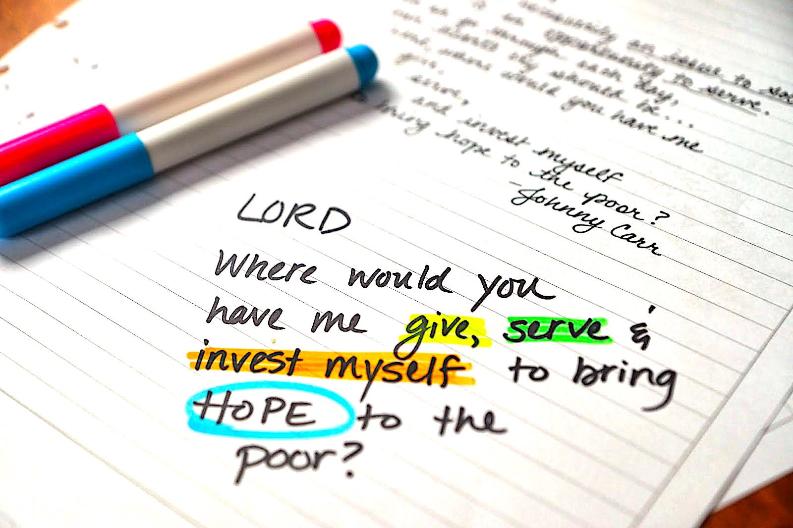
Lord, we are willing to be made willing. Please move the old obstacles out of the way of serving You.

Well, precious Heartdwellers—grieving or rejoicing—the Lord has asked me to give you examples of what anyone of you that are not disabled, can do. So many questions, so much insecurity and a sense of mystery about what you can do to show the world Jesus.

Let’s dismantle this right now. As far as the demonic opposition to you goes, let’s pray this short prayer.

"In the Name of Jesus, I renounce confusion, laziness, lukewarmness, selfishness, blindness & deafness. Every discouraging & misleading lie, 'not knowing', procrastination, discouragement, unbelief and a spirit of sabotage.

"I bind your communication, backup, & retaliation. In Jesus Name, I silence and bind EVERY demon associated with blocking my mission in Christ and bind his excrement to him. And I command you, in Jesus' Name to go to His feet, for Him to deal with you right now.

"I will stop saying, 'I don’t know.' and start confessing God’s faithfulness: "I will lead the blind by a way they do not know, In paths they do not know I will guide them. I will make darkness into light before them And rugged places into plains. These are the things I will do, And I will not leave them undone." Isaiah 42:16

Another part of this prayer:

"Holy Spirit, please cleanse my mind of every impediment, fill me with Your light and especially guide me into my calling in Jesus. Remove every unrighteous attitude from my heart that I may present myself as a living sacrifice to the Lord, my God."

OK, that's the prayer. You may want to rework that a little bit, if you want to. BTW, I stopped sending demons to the pit because I felt the Lord should be directing demon traffic, so I send them to His feet now. And that bit of wisdom come from a world-class deliverance ministry, which I've been following for quite a long time and is very effective.

So, it is a little presumptuous for us to dispose of them according to our understanding. You will see more of this when I give you the new revision of the binding prayer.

So, moving on. What can you do to serve God?

Begin by looking at those around you and asking Holy Spirit to send the needy to you, that you have the resources to help. Anything you can do for yourself—you can do for others, simply sharing with them, "Jesus sent me to help you." or "I see you can’t carry that package. If Jesus were here, He would help you—may I?" Or just offer to help and afterwards tell them, "God loves you and He’s always watching over you." Things like that are simple and non-threatening.

So, what are some of the everyday things we do for ourselves? Shop, go to the Dr., sweep our porch, take out the trash, mow the lawn, wash the car, work on the computer. And btw, the elderly especially have problems comprehending computers. But if they master that, or their IPhone or whatever they have, they can be in touch with their children and grandchildren, which is a real morale booster. So, helping an elderly person with that is a very substantial work of mercy.

You can take people to church with you, or an event they might enjoy: a state fair, a movie, a concert. Anything you are capable of doing for yourself, you can do as an act of love and charity for others. Nursing, cleaning, running errands etc. All those things build up and count as works of mercy.

If there is a shelter or food bank around, you can volunteer on days they pass out food. If there are homeless living near you, you can buy them a few dollar burgers and a drink. We normally do not give cash to the homeless unless we know for sure it won’t end up in a drug dealer's pocket.

With winter coming on, the homeless suffer from many necessities: socks, shoes, rain gear, warm clothing. You can buy things at the thrift store if you are on a budget. When you pass out food or drink to them, you can look at the condition of their shoes and ask what size they wear. We have seen homeless so desperate for shoes, they'll take women’s shoes and cut out the toes. THAT is desperate.

If you are a musician, you can play music at a nursing home on a certain day of the week and have a communion service. They need encouragement; depression is a huge problem. Also, just listening to their stories brings them comfort; they don’t feel so useless when someone cares enough to spend time with them.

You can visit inmates at the city jail and share with them what Jesus has done for you, personally. You can also pray with them and have a communion service. Use a Rhema Scripture for encouragement. When you go where Holy Spirit wants you to go, He equips and empowers you. You can organize a very small prayer group and have a bake sale using the proceeds to buy blankets for the homeless.

Really, the Holy Spirit is so ingenious. With His ingenuity and your willingness, there are so many ways you can help others.

You can pass out food and drinks to those on the street. Drinks are very welcome, especially in the summertime. Be careful with what you get for food, most have tooth problems or no teeth at all. If you are mechanically inclined, you can help fix a neighbor’s car, change the oil, etc.

These are starter suggestions. Once you begin to get involved in people’s lives, the Lord can steer you and perhaps narrow down what He wants you to do to help. This is traveling towards your destination. You haven't gotten there yet - you're only starting out. And eventually, the Lord will lead you to the discovery of what He created you to do.

If you are homebound and disabled, you have a powerful influence before God because of your sufferings. Prayer is the most important one; when you see a need, pray for them. Get involved in forums and channel discussions to bring the light of Jesus’ love to people.

There are so many lost and lonely teens who don’t know up from down—here you can help bring them encouragement, grounding, and prayer. You can cultivate relationships that help them to get a handle on their lives. And especially straighten out wrong concepts of God and the coming Tribulation.

You can also make telephone calls and send e-mails and messages to people. You can begin a blog and start sharing it with any channel you’re on.

For those of you who have been offended by the terrible things they say about us and the Lord, you can make a video sharing how Jesus has helped you and changed your life on this channel. You can pray for those who are attacking us. Some are Satanists, some are misguided and misinformed Christians that just don’t go deep enough. I am especially grieved by the way they turn away new Christians from our channel. I wish someone would speak up in the Lord’s defense, because He wants more than anything to bring these young ones, who are so confused by all these different doctrines and church rules... He want to bring them into an intimate relationship with Him. And that's why we've been targeted. Satan fears that more than anything.

